**PRACTICAL NO :2**

**COMMANDS-**

**> show databases**

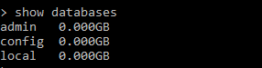

**> db**



**> use books**



(optional) if we want to delect db the command is –



Collection name - beginnersbook

**> db.beginnersbook.insert({ name: "bhavans", age: 50, website: "beginnersbook.com"})**

 **> db.createCollection("teachers",{capped : true,size :123456})**



**> show collections**



**> db.teachers.drop()**



**> show collections**



**> db.beginnersbook.find()**



**> db.beginnersbook.find().pretty()**

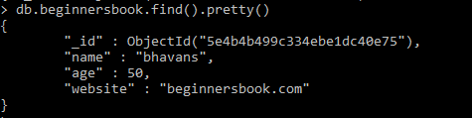

**> db.beginnersbook.find({name :"bhavans"}).pretty()**

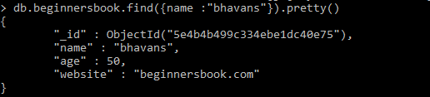

Greater than

**> db.beginnersbook.find({age :{$gt:12}}).pretty()**

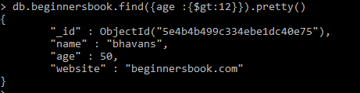

Less than

**> db.beginnersbook.find({age :{$lt:65}}).pretty()**

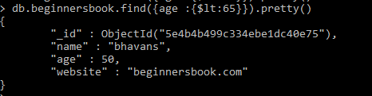

Not equal to

**> db.beginnersbook.find({age :{$ne:5}}).pretty()**

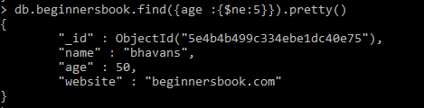

**> db.beginnersbook.update({"name":"bhavans"},{$set:{"name":"abcd"}})**



**> db.beginnersbook.find()**

Insert a new row

**> db.beginnersbook.insert({"name":"tycs" , age:30,website:"beginnersbook.com"})**



Delete row

**> db.beginnersbook.remove({"name":"tycs" , age:30,website:"beginnersbook.com"})**



**> db.beginnersbook.find().limit(1).pretty()**

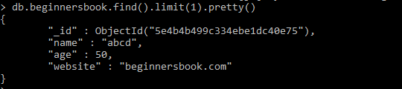

**> db.beginnersbook.find().limit(1).skip(1).pretty()**

No op because it has 1 row

**> db.beginnersbook.insert({"name":"andheri" , age:80,website:"beginnersbook.com"})**

**> db.beginnersbook.insert({"name":"jogeshwari" , age:40,website:"beginnersbook.com"})**

**> db.beginnersbook.find()**

**> db.beginnersbook.find({},{"_id":1,"name":1}).sort({"name":1})**

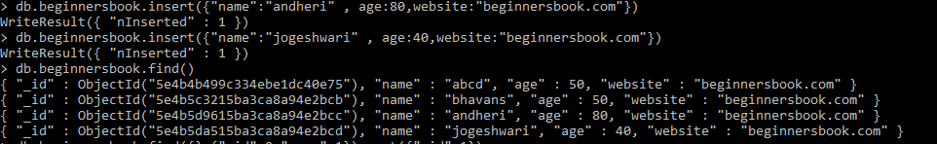

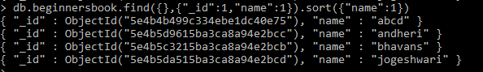

**> db.beginnersbook.remove({})**

